
Faculty of Computers and Information, Assiut University

Money Mirror
Software Requirements Specifications
Submitted by:
1. Jannah Ayman Abdelraouf (CS)
2. Nancy Saad Muhammad (CS)
3. Rawan Sotohy Mohammed (CS)
4. Arwa Hassan Mohammed (IS)
5. Rahma Tarek Mohammed (IS)
6. Doha Emad Abdeltawab (IS)
Submitted to:
Dr. Marwa Hussien

Table of Contents
Table of Contents ii
Revision History ii
1. Introduction 1
1.1 Purpose 1
1.2 Intended Audience and Reading Suggestions 1
1.3 Product Scope 1
2. Overall Description 2
2.1 Product Perspective 2
2.2 Product Functions 2
2.3 User Classes and Characteristics 5
2.4 Assumptions and Dependencies 6
2.5 Design and Implementation Constraints 6
2.6 User Documentation 6
3. External Interface Requirements 7
3.1 User Interfaces 7
3.2 Hardware Interfaces 11
3.3 Software Interfaces 11
3.4 Communications Interfaces 12
4. Specific Requirements 13
4.1 Relational Schema 13
4.2 Use Case Diagram 14
4.3 Detailed Use Cases 15
4.3 Activity Diagrams 34
5. Feasibility Analysis 51
5.1 Executive Summary 51
5.2 Technical Feasibility 51
5.3 Market Feasibility 52
5.4 Risk Analysis 53
6. Nonfunctional Requirements 54
6.1 Performance Requirements 54
6.2 Safety Requirements 54
6.3 Security Requirements 54
6.4 Software Quality Attributes 55

Introduction

Purpose
This Software Requirements Specification (SRS) describes the functional and nonfunctional requirements for the Money Mirror mobile application. It serves as a contract between the development team and stakeholders to ensure the system meets user needs and project objectives.

Intended Audience and Reading Suggestions
The intended audience of this document includes the project development team, parents seeking to guide their children's financial decisions, or guardians.
Reading suggestions:
- Read 1.3 Product Scope for a high-level overview of the app's goals and boundaries.
- Skim 2.2 Product Functions for a summary of core capabilities.
- Dive into 4.3 Use Cases for detailed scenarios on parent/child interactions.
- Review 3 External Interface Requirements and 5 Nonfunctional Requirements for technical and quality details.

Product Scope
Money Mirror is a cross-platform mobile application that enables parents to monitor their children’s (aged 6–14) spending habits and promote financial literacy through AI-driven personality insights and interactive, gamified features.
The system provides:
- Parents: real-time expense tracking, allowance management, AI-generated behavioral profiles (e.g., “Impulsive Spender”), detailed reports, and multi-child dashboards.
- Children: simple expense logging with mood emojis, visual savings goals, story-based financial quizzes, achievement badges, and a friendly animated character guide.
Out of scope: real financial transactions, banking integration, or a web version.
The application operates as a educational tool, using cloud APIs for sync and notifications, with a focus on privacy, engagement, and actionable family insights.

Overall Description

Product Perspective
Money Mirror is a new, mobile application addressing a gap in existing financial literacy tools. Unlike transaction-focused apps (e.g., Greenlight, GoHenry), it emphasizes behavioral analysis and gamified education without requiring real banking integration. It operates independently but uses cloud APIs for notifications and asset storage.

Product Functions
Function 1 | Parent and Child Signup
Input | Parent email, password, child name, generated login code
Output | Account records created, child login codes generated, confirmation message
Processing | Validate inputs, create accounts for parent and children, generate and store unique child login codes in database

Function 2 | Multi-Child Support
Input | Parent login credentials, request to view/manage child profiles
Output | List of children under parent account, selected child's profile and data displayed
Processing | Retrieve child profiles linked to parent, enable switching between profiles, fetch associated expenses and goals

Function 3 | Personality Profiling
Input | Questionnaire responses, spending and mood logs
Output | Financial personality profile with insights, stored in database. For example, the AI may classify a child as an "Impulsive Spender" (for child: "Speedy Spender") with traits like quick purchases driven by excitement or low savings ratios. Other possible types include "Prudent Saver" ("Treasure Keeper") focusing on high savings and deliberate decisions; "Goal-Oriented Planner" ("Dream Builder") with steady goal contributions; or "Bargain Hunter" ("Deal Detective") emphasizing value and deals. These types evolve over time as more expense, mood, and quiz data is collected.
Processing | Analyze questionnaire and logs using AI/NLP, generate personality traits, update child’s profile

Function 4 | Allowance Management
Input | Weekly/monthly allowance amount, bonus settings, child selection
Output | Updated allowance records, confirmation message
Processing | Store allowance amounts and schedules, log bonus payments, update child’s allowance history

Function 5 | Savings Goals Tracking
Input | Savings goal description, target amount, duration, user type (parent/child)
Output | Visual progress bar, achievement notifications, goal status updates
Processing | Record goals, update progress based on expenses, trigger rewards and visuals on milestones

Function 6 | Expense Logging
Input | Expense amount, category, mood emoji, optional notes
Output | Expense record created and stored, confirmation message
Processing | Validate expense data, associate with child account, store mood and notes in database

Function 7 | Expense Viewing
Input | Selected child profile (for parents), time/category filters, user login credentials
Output | Filtered list of expenses with details (amount, category, mood, date)
Processing | Retrieve expense records from database linked to the user/child account, apply filters, generate kid-friendly visuals for children or detailed reports for parents

Function 8 | Statistical Analysis
Input | Expense records, mood logs, time period filters
Output | Summary reports, charts with spending trends, mood correlations
Processing | Aggregate and analyze data, generate visual reports highlighting spending and mood patterns

Function 9 | Interactive Story Quiz
Input | Child login credentials, quiz selection (e.g., savings scenario), multiple-choice responses
Output | Friendly story scenario, feedback on choices (correct/incorrect with explanations).
Processing | Load pre-defined or AI-generated story templates from database, evaluate responses against financial rules, trigger animations/character reactions.

Function 10 | Notification Alerts System
Input | Trigger events (e.g., goal progress, expense logged), user preferences (enabled/disabled, email/push)
Output | In-app push notifications or email alerts with links
Processing | Monitor system events via backend triggers, format messages based on user type/severity, send via SignalR (in-app) or SendGrid (email)

Function 11 | Achievements
Input | Child action data (e.g., goal reached, consistent logging), predefined milestone criteria
Output | Unlocked badge/trophy icons, celebration animation/message from character guide, updated trophy case display
Processing | Compare action data against achievement rules in database, unlock and assign rewards if met, store details in child's profile

User Classes and Characteristics
Money Mirror defines two main user classes to manage access and functionality appropriately:
- Parent
  - Primary account holders, typically adults with basic smartphone proficiency, responsible for overseeing their children’s financial activities. They require tools to monitor and guide spending (see 2.2 Product Functions, 3.1 User Interfaces).
- Child
  - Users aged 6–14 with limited technical skills, requiring an engaging, intuitive interface for learning financial concepts (see 2.2 Product Functions, 3.1 User Interfaces).

Assumptions and Dependencies
The project assumes reliable internet for AI processing (e.g., spaCy, scikit-learn). Third-party tools (e.g., ASP.NET Core, SQL Server) are assumed functional without additional licensing issues, affecting requirements if unsupported.

Design and Implementation Constraints
The Money Mirror project must deliver a reliable, maintainable mobile app within defined limits to ensure feasibility:
- Platform: Must use React Native for cross-platform development targeting Android and iOS; defer web/desktop versions due to time and resource constraints.
- Hardware: Minimum 4 GB RAM required for smooth AI processing, chart rendering, and animations.
- UI Design: Prioritize simple, child-friendly interfaces with basic animations; avoid complex graphics to support diverse device compatibility.
- AI/Backend: Must leverage established tools like spaCy for NLP and ASP.NET Core for the API, with AI models optimized for offline capability to handle poor connectivity.

User Documentation
There will be a 5-10 minute video tutorial hosted on YouTube (e.g., "How to Log Expenses," "Setting Up Savings Goals," "Understanding AI Insights"), linked directly in the app's help section for quick access.

External Interface Requirements

User Interfaces
The Money Mirror application features a user-friendly, colorful interface tailored for both parents and children aged 6–14. The interface includes:
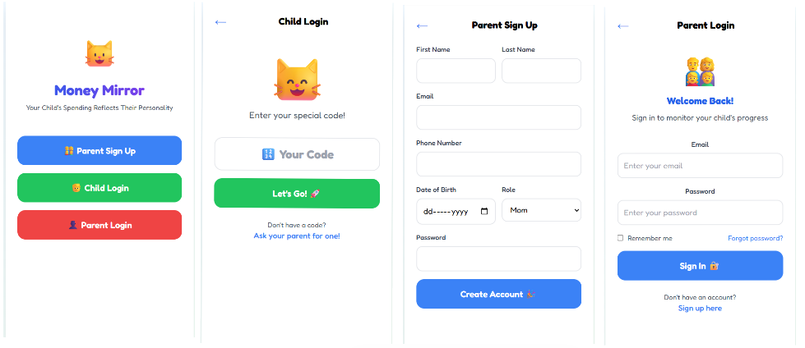
Landing Page Child Login Parent Sign-up Parent Login
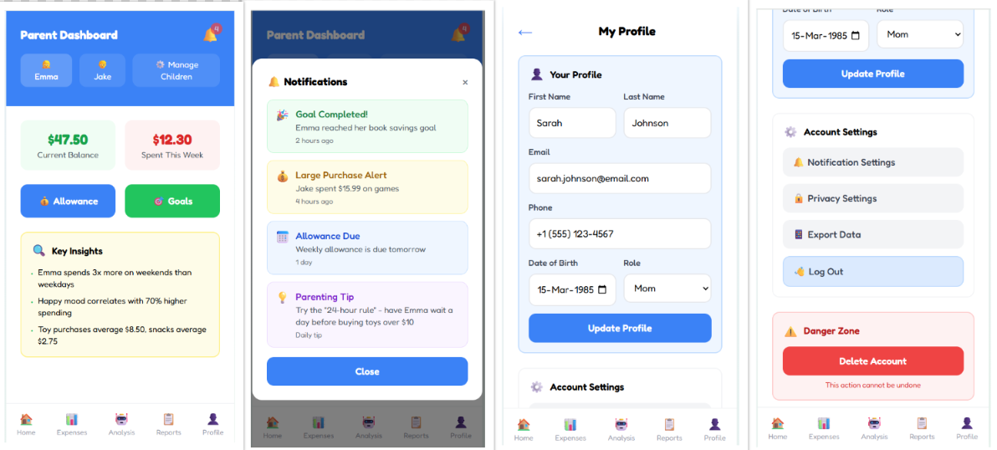
Parent Dashboard Parent’s Notification Parent’s Profile I Parent’s profile II
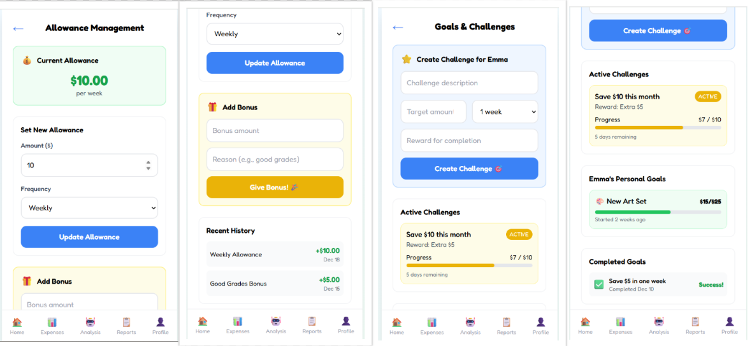
Allowance Management I Allowance Management II Goals & Challenges I Goals & Challenges II

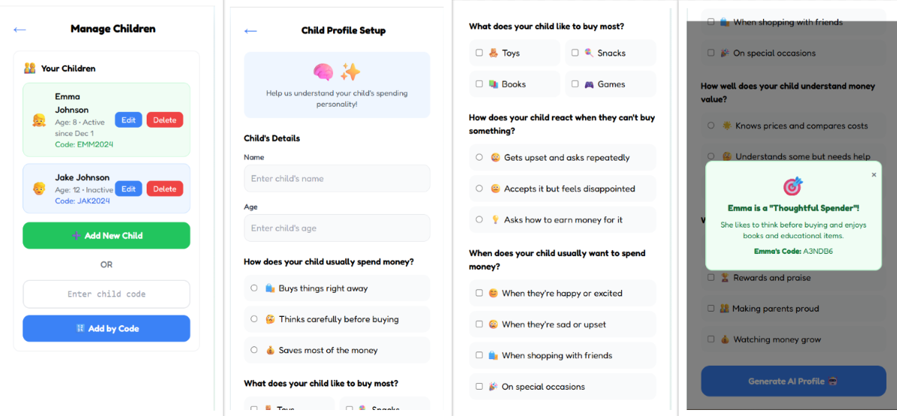
Manage Children Adding New Child I Adding New Child II Initial Profiling
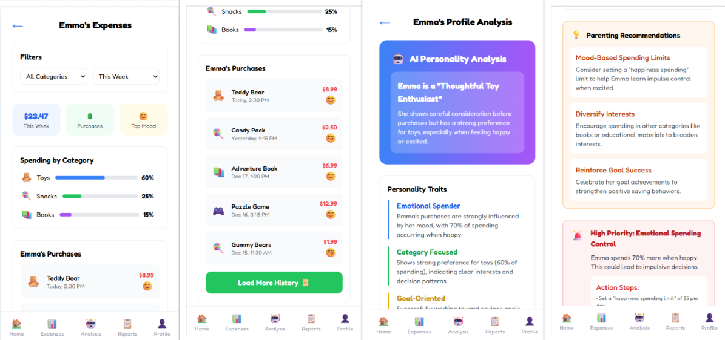
Expense History I Expense History II Profile Analysis I Profile Analysis II
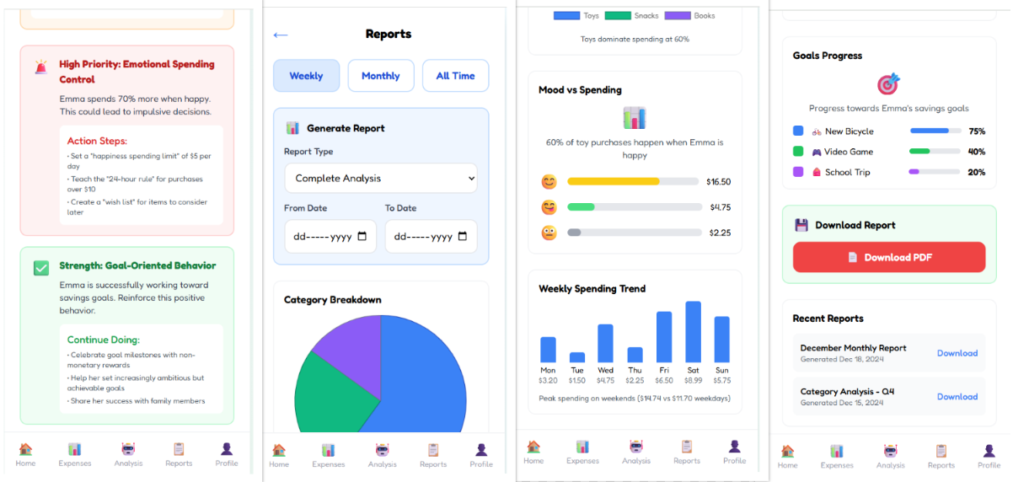
Profile Analysis III Reports I Reports II Reports III
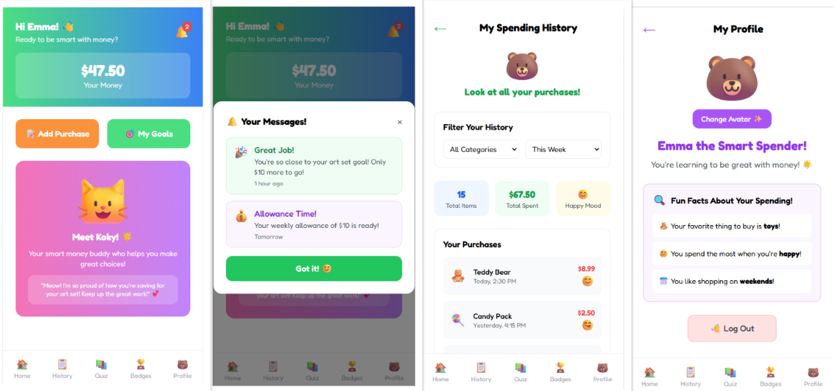
Child Dashboard Child Notifications Spending History I Spending History II
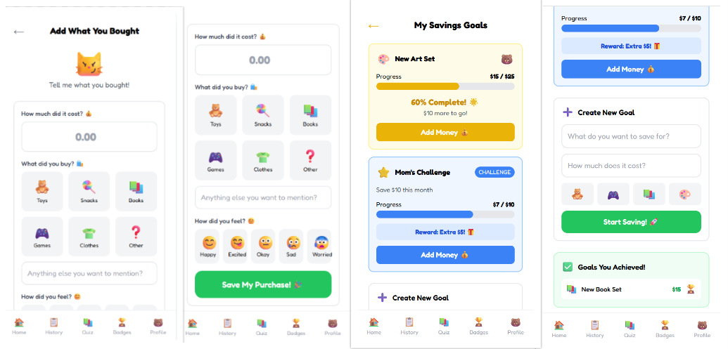
Logging Expenses I Logging Expenses II Savings Goals I Savings Goals II
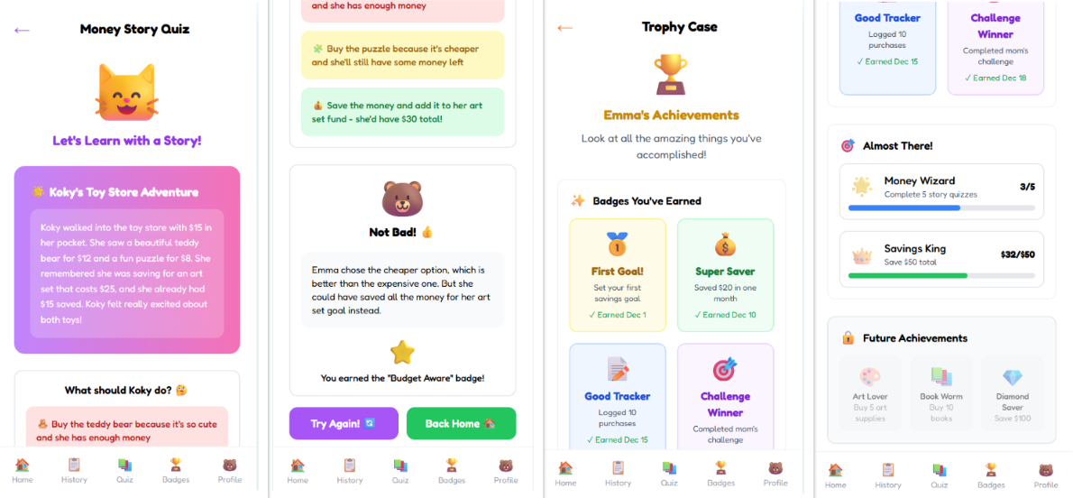
Story Quiz I Story Quiz II Achievements I Achievements II

Hardware Interfaces
Money Mirror is optimized for mobile hardware, emphasizing touch-based interactions:
- Touchscreen: Required for all inputs, including swipe gestures for navigation, emoji/mood selection, and drag-to-set goals.
- Processor and RAM: Minimum 1.5 GHz and 4 GB to handle AI analysis and animations.
- Supported Devices: Android 9.0+ and iOS 11+ smartphones/tablets.
- Network: Wi-Fi/mobile data for sync.

Software Interfaces
- Frontend: React Native (cross-platform mobile UI)
- Backend: ASP.NET Core Web API 6.0+ with Identity + JWT for secure authentication.
- Database: SQL Server 2019+ for storing user credentials, expenses, moods, personality profiles, goals, and achievements.
- AI Layer: Python (spaCy, scikit-learn, and Transformers) for NLP and AI analysis, accessed via a REST API.
- Asset Hosting: Cloudinary.

Communications Interfaces
- Internet Connection: Stable connection required for real-time sync.
- Protocols: HTTP/HTTPS for API calls.
- Email Notifications: For parents (e.g., profile updates, weekly reports), sent via SendGrid.
- In-App Notifications: For children and parents, using SignalR for real-time delivery.

Specific Requirements

Relational Schema
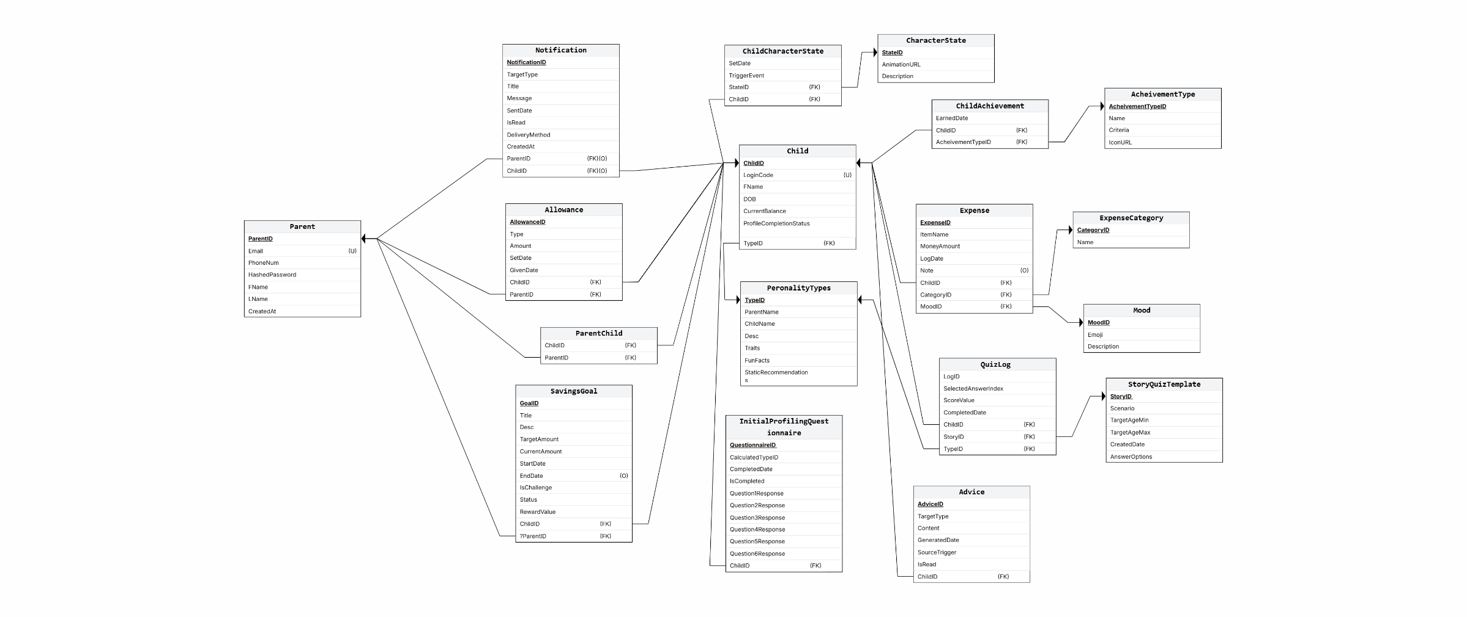

Use Case Diagram
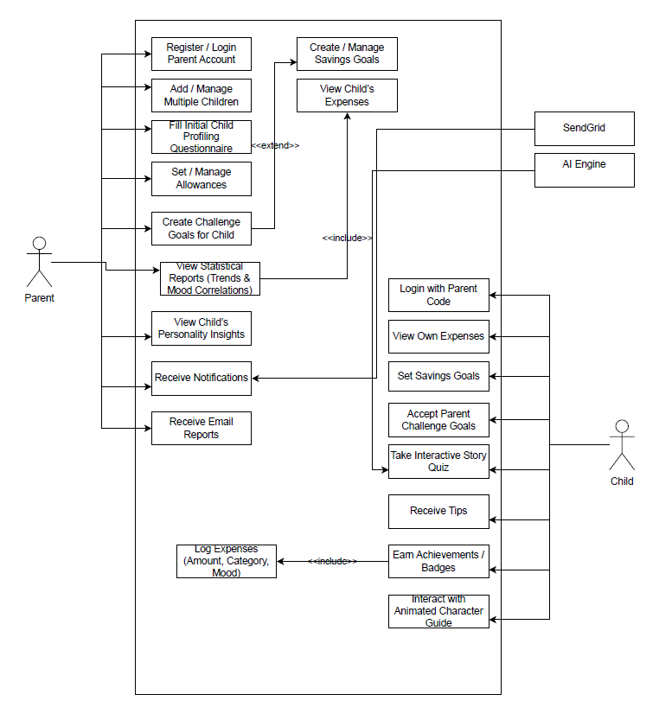

Detailed Use Cases

Use Case Name: Parent Signup and Child Code Generation | ID: UC-1a | Priority: High
Actor: Parent
Description: Allows a parent to sign up using email and password to create an account and generate unique login codes for each child.
Trigger: A parent wants to create an account and generate login codes for their children.
Type: External
Precondition:
- The app is available and operational.
- The parent has a valid email address.

Normal Course:
1- The parent selects “Sign Up.”
2- The parent enters their email and password in the registration form.
3- The system creates the parent’s account.
4- The system validate parent info
4- The system prompts the parent to add children.
5- For each child, the system generates a unique login code.
6- The parent saves or shares the code for each child.
Post condition:
- The parent’s account and credentials are stored in the database.
- A unique login code is generated for each child.

Use Case Name: Child Login Using Parent Code | ID: UC-1b | Priority: High
Actor: Child
Description: Allows a child to log in securely using the unique code provided by the parent.
Trigger: A child wants to log in using the code provided by the parent.
Type: External
Precondition:
- The app is available and operational.
- A unique code for the child exists in the system.
Normal Course:
1- The child selects “Child Login.”
2- The child enters the unique code in the login form.
3- The system verifies the code.
4- The system grants access and loads the child’s profile.
Post condition:
- The child is logged in to their account.
- The system links the session to the correct parent account.

Use Case Name: Multi-Child Support for Parents | ID: UC-2 | Priority: High
Actor: Parent
Description: Allows parents to manage multiple children’s accounts within a single parent account, switching between them through a sidebar to view each child’s expenses, profiles, savings goals, and mood trends.
Trigger: A parent wants to view or manage a different child’s account.
Type: External
Precondition:
- The parent is logged in.
- Multiple child accounts exist under the parent’s account.
- The app is available and operational.

Normal Course:
1- The app displays dashboard of all children linked to the parent’s account.
2- The parent selects a child from the dashboard .
3- The app loads the selected child’s dashboard, showing expenses, profiles, goals, and mood trends.
4- The parent can switch to another child at any time by selecting a different name in the sidebar.

Post condition:
- The parent successfully views and manages data for the selected child.
- The system securely loads and separates each child’s data.

Use Case Name: Initial Profiling for New Child | ID: UC-3 | Priority: High
Actor: Parent
Description: Allows parents to complete a questionnaire when adding a new child to establish a preliminary financial personality profile. Provides immediate insights into the child’s potential financial behaviors.
Trigger: A parent adds a new child to their account and wants to create a preliminary financial profile.
Type: External
Precondition:
- The parent is logged in.
- A new child record is being added.
- The app and questionnaire module are operational.

Normal Course:
1- The parent selects “Add New Child” from the app.
2- The app presents an initial profiling questionnaire (questions about the child’s spending and decision habits).
3- The parent completes and submits the questionnaire.
4- The system processes the responses.
5- The app generates an initial financial personality profile for the child.
6- The parent reviews the generated profile on the dashboard
Post condition:
- The child’s preliminary financial personality profile is stored in the database.
- Parents gain immediate insights into the child’s potential financial behaviors.

Use Case Name: Allowance Management for Children | ID: UC-4 | Priority: High
Actor: Parent
Description: Allows parents to set weekly or monthly allowances for each child, add one-time bonus money, and view allowance usage history.
Trigger: A parent wants to manage allowances (set, update, or view history) for a child.
Type: External
Precondition:
- The parent is logged in.
- The child account exists under the parent’s account.
-The app and allowance module are operational.

Normal Course:
1- The parent selects a child from their dashboard.
2- The parent navigates to the “Allowance” section.
3- The app displays current allowance settings and history.
4- The parent sets a weekly or monthly allowance amount.
5- The parent optionally adds a one-time bonus allowance (e.g., for good behavior).
6- The system stores the new allowance or bonus in the database.
7- The app updates and displays the allowance usage history for the selected child.
Post condition:
- The child’s allowance settings (recurring and bonus) are stored in the database.
- The parent can view updated allowance history at any time.

Use Case Name: Child Savings Goals Tracking | ID: UC-5a | Priority: High
Actor: Child
Description: Allows a child to create their own savings goals for specific categories, track progress with colorful progress bars, and receive encouraging messages from the character guide.
Children can also view and accept parent-set goals that offer rewards such as bonus allowance or achievement badges.
Trigger: A child wants to create, view, or accept a savings goal.
Type: External
Precondition:
- The app is operational.
- The child is logged in.

Normal Course:
1- The child selects “Savings Goals.”
2- The child creates a new savings goal (entering name, category, target amount).
3- The app displays a progress bar for the goal.
4- The child adds money to the goal.
5- The child views available parent-set goals (marked with a star).
Post condition:
- The child’s goals and progress are stored in the database.
- Visual feedback and character guide messages are updated in real time.

Use Case Name: Parent Challenge Goal Management | ID: UC-5b | Priority: High
Actor: Parent
Description: Allows a parent to set challenge goals for their children to encourage specific financial behaviors, and monitor progress for both child-set and parent-set goals while receiving updates via notifications.
Trigger: A parent wants to set a challenge goal or monitor a child’s goal progress.
Type: External
Precondition:
- The parent is logged in.
- The child account exists under the parent’s account.
- The app is operational.

Normal Course:
1- The parent selects a child from the dashboard.
2- The parent navigates to the “Challenge Goals” section.
3- The parent sets a challenge goal (description, duration, reward).
4- The app stores the challenge goal in the database.
5- The parent monitors progress for both child-set and parent-set goals.
6- The system sends notifications to the parent about goal updates.
Post condition:
- Parent-set goals are stored in the database.
- Progress and notifications are updated in real time.
- The parent has visibility into the child’s savings behavior.

Use Case Name: Expense Logging for children | ID: UC-6 | Priority: High
Actor: children
Description: Allow children to log expenses and store expenses information, viewable by parents.
Trigger: A new expense needs to be recorded by a child.
Type: External
Precondition:
-The app is operational and accessible to children.
Normal Course
1- child select Add Purchase
2- A child logs an expense with the following details:
- Amount
- Category, selected by the child based on the item purchased
- Mood, chosen by the child to reflect their feeling
3- The app validates the entered information.
4- The app saves the expense details in the database.
5- The app confirms to the child that the expense has been saved successfully.
Post condition
- Expense information is recorded in database, available for parent viewing.

Use Case Name: Expense Viewing by Children | ID: UC-7a | Priority: High
Actor: children
Description: Allow children to view their expense logs in a kid-friendly interface.
Trigger: A child wants to review the expenses History.
Type: External
Precondition:
-The app is operational and accessible to child.
-The child has logged expenses.
Normal Course
1- The child selects the expense History section.
2- The app displays a visual character to guide the child.
3- The child can filter purchases by category or time.
4- The app generates a dashboard showing the total number of purchases, the cost and the child’s moods.
5- The app displays a list of purchases with the item name, date, and mood for each entry.

Post condition
- The child can view and interact with their expense data in an engaging and informative way.

Use Case Name: Expense Viewing by Parent | ID: UC-7b | Priority: High
Actor: Parents
Description: Allow parents to view the selected child expenses History
Trigger: A parent wants to review a child’s expenses.
Type: External
Precondition:
- The parent is logged in and expenses have been logged for at least one child.
Normal Course
1- The parent selects a child from a dashboard listing their children.
2- The parent selects the expense section for the selected child
3- The app displays the child’s expenses.
4- The parent can filter by category or date.
5- The app generates a dashboard showing:
- Categories the child purchased from and the percentage of money spent on each.
- Total amount spent by the child.
- Number of items purchased by the child.
- The child’s mood associated with purchases.
6- The app displays a detailed list of all purchases, including the item name, date, and mood for each entry.
Post condition
- Parents gain detailed insights into a child’s expense data through a comprehensive dashboard and list.

Use Case Name: View Financial Behavior Profile | ID: UC-8 | Priority: High
Actor: Parents
Description: Allow parents to view AI-analyzed financial behaviors of children.
Trigger: A parent requests behavior insights.
Type: External
Precondition:
-The parent is logged in and sufficient data (expenses, moods) is available.
- AI module has analyzed data and generated classification
Normal Course
1- The parent selects a child from a dashboard listing their children.
2- The parent selects the Analysis section for the selected child
3- The app analyzes spending patterns, moods, and notes
4- The app shows the following:
- Personality classification and Description about this personality
- Personality Traits
- Personality Recommendation
- Personality Notes
5- The app displays dashboard that show the following:
- Average Purchase
- Weekly Frequency
- Peek spending
- Goal Progress
Post condition
- Parent successfully views AI-driven personality classification and dashboard insights to better understand and guide the child’s financial behavior.

Use Case Name: View Updated Personality Profiling for children | ID: UC-9 | Priority: High
Actor: children
Description: Allow children to receive updated, fun personality labels and tips based on spending and moods.
Trigger: System updates the child’s financial personality profile.
Type: External
Precondition:
-The child is logged in and data has been updated
-AI module has processed the data and generated updated profile
Normal Course:
1- the child selects Profile section.
2- The app displays an avatar or character; the child can change it.
3- The app shows the money personality and description about it in a child-friendly and cute way.
4- The app displays the status, including:
- Favorite category the child buys from a lot and the percentage of spending on it.
- The child's mood.
- Spending frequency.
6- The child views simple, encouraging tips with visuals like animated characters.
Post condition:
- Child receives engaging feedback that reinforces positive financial behavior through playful labels, tips, and visuals.

Use Case Name: View Statistical Analysis | ID: UC-10 | Priority: High
Actor: Parents
Description: Parent accesses detailed reports on the child’s spending patterns.
Trigger: A parent requests statistical reports.
Type: External
Precondition:
-The parent is logged in and data about expenses has been updated.
-The system has generated statistical data based on expense and mood logs
Normal Course:
1- Parent access Report section
2- Parent selects a reporting period.
3- Parent selects a report Category and its date.
4- App generates visual reports including:
- Category breakdowns.
- Mood correlations.
- Spending trends over time.
5-System calculates Key Insights, such as:
- Total amount spent compared to the previous period.
- Most common mood associated with spending.
- Average spending for each category.
5-App displays data using charts.
6-Parent reviews insights to understand spending patterns
Post condition:
-Parent successfully views detailed statistical reports that highlight the child’s spending behavior and mood influences.

Use Case Name: Interactive Story Quiz for Children | ID: UC-11 | Priority: High
Actor: children
Description: Allow children to participate in an interactive story-based financial quiz, where they are placed in short, personalized story scenarios and make financial choices.
Trigger: A child wants to play a financial quiz.
Type: External
Precondition:
- The child is logged into the app.
- The app is operational and story data is available.
Normal Course:
1- The child selects the “Story Quiz” option.
2- The app generates a short personalized story with a financial decision point.
3- The child chooses an answer from multiple-choice options.
4- The app evaluates the answer:
- If correct → A happy ending is shown with animated character celebration.
- If incorrect → The app explains why the choice was wrong with a sad reaction .
5- The app updates the child’s badge/score progress.
6- The app confirms quiz completion.

Post condition:
- The child receives immediate feedback on their financial choices.
- Progress is stored in the database.

Use Case Name: Receiving Notification Alerts (Children) | ID: UC-12a | Priority: High
Actor: Children
Description: Allow children to receive fun and encouraging notifications that remind them to log expenses, check savings goals, and reinforce positive financial behavior.
Trigger: The system pushes a notification for reminders, progress updates, or advice.
Type: External
Precondition:
- The child is logged into the app.
- Notifications are enabled for the child’s account.
Normal Course:
1- The app generates a notification (e.g., reminder to log expenses).
2- The system sends the notification to the child’s device in real time.
3- The child receives the notification in a kid-friendly tone with visuals (e.g., “Great job saving, keep it up!”).
4- The child taps the notification to open the related app section (e.g., log expense, view goal progress).
5- The app updates actions in the database (e.g., expense logged, progress checked).
Post condition:
- Children are reminded and encouraged to engage with the app regularly.

Use Case Name: Receiving Notification Alerts (Parents) | ID: UC-12b | Priority: High
Actor: Parents
Description: Allow parents to receive alerts about savings goal updates, spending behavior, and mood/expense trends to stay informed of their child’s progress.
Trigger: The system pushes a notification when relevant updates or insights are available.
Type: External
Precondition:
- The parent is logged into the app.
- Notifications are enabled for the parent’s account.
Normal course:
1- The app generates a notification (e.g., savings goal reached, new spending trend detected).
2- The system sends the notification to the parent’s device in real time.
3- The parent receives the notification with a summary message (e.g., “Your child reached their savings goal!”).
4- The parent taps the notification to view more details inside the app.
5- The system logs the notification for future reference.
Post condition
- Parents stay informed about their child’s financial activities and progress.

Use Case Name: Earning Achievements (Children) | ID: UC-13 | Priority: High
Actor: children
Description: Allow children to earn badges and trophies when they reach savings goals, consistently log expenses, or demonstrate positive financial behavior.
Trigger: A child completes an action that qualifies for an achievement.
Type: External
Precondition:
- The child is logged into the app.
- Achievement logic is active in the system.
Normal Course
1- The child performs an action that qualifies for an achievement.
2- The system detects the milestone (e.g., goal reached, consistent logging).
3- The app unlocks a badge/trophy for the child.
4- The animated character guide celebrates the achievement.
5- The new badge appears in the child’s “Trophy Case.”
6- The app stores achievement details in the database.
Post condition
- Child receives a badge/trophy reinforcing positive financial habits.
- Achievements are saved and can be displayed later.

Use Case Name: Interactive Character Guide (Children) | ID: UC-14 | Priority: High
Actor: Children
Description: Allow children to interact with a friendly animated character that guides them through the app, reacts to their actions, and provides advice in a playful manner.
Trigger: The child performs an in-app action (e.g., logging expenses, overspending, or reaching a savings goal).
Type: External
Precondition:
- The child is logged into the app.
- Character animations and reactions are configured in the system.
Normal Course:
1- The child logs into the app and sees the animated character.
2- The child performs an action (e.g., logs expense, updates savings goal).
3- The system triggers the character’s response:
- Happy reaction → Reaching a savings goal or consistent logging.
- Sad reaction → Overspending or exceeding allowance.
4- The character provides playful advice or encouragement (e.g., “Oops! You spent a lot on toys, let’s save next time!”).
5- The app saves the character’s reaction in the database.
Post condition:
- Child receives playful, visual feedback tied to financial behavior.

Use Case Name: Email Notifications for Parents | ID: UC-15 | Priority: High
Actor: Parents
Description: Allow parents to receive email notifications for important updates such as changes to a child’s financial personality profile or availability of weekly reports.
Trigger: The system detects an important event (e.g., profile update, report generation) and sends an email notification.
Type: External
Precondition:
- The parent is logged into the app.
- The parent has a verified email address.
- Email notifications are enabled for the account.
Normal Course:
1- The system identifies an event that triggers an email (e.g., updated profile, new report available).
2- The app generates an email with the relevant details.
3- The system sends the email via SendGrid to the parent’s registered address.
4- The parent receives the email containing:
- Notification type (e.g., “Your child’s profile updated to ‘Cautious Saver’”).
- A summary of the update.
- A link to view details inside the app.
5- The parent clicks the link and is redirected to the app for full details.
6- The app logs confirmation that the email was sent and viewed.
Post condition:
- Parents are informed of important updates through timely email notifications.

Activity Diagram

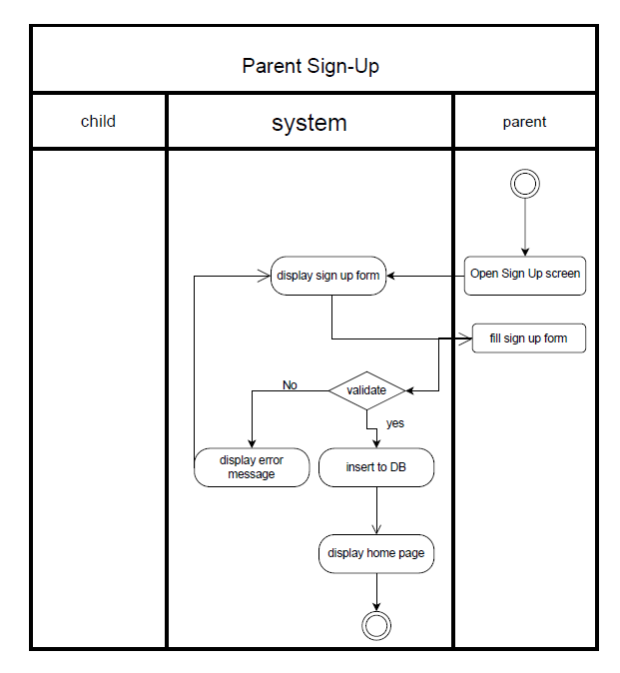

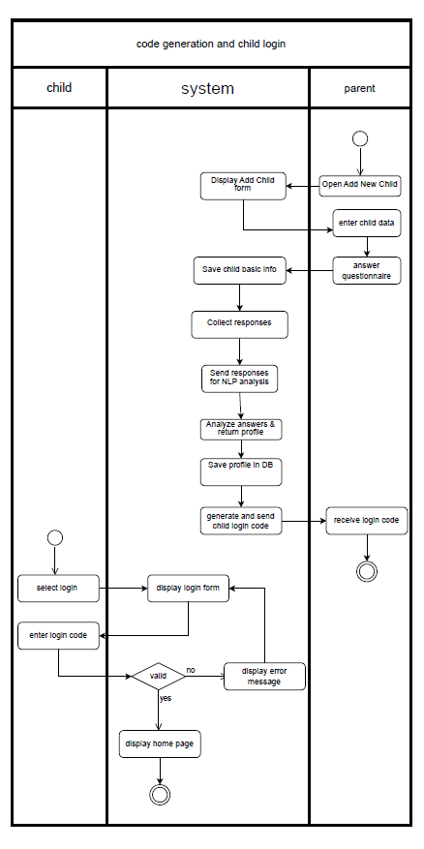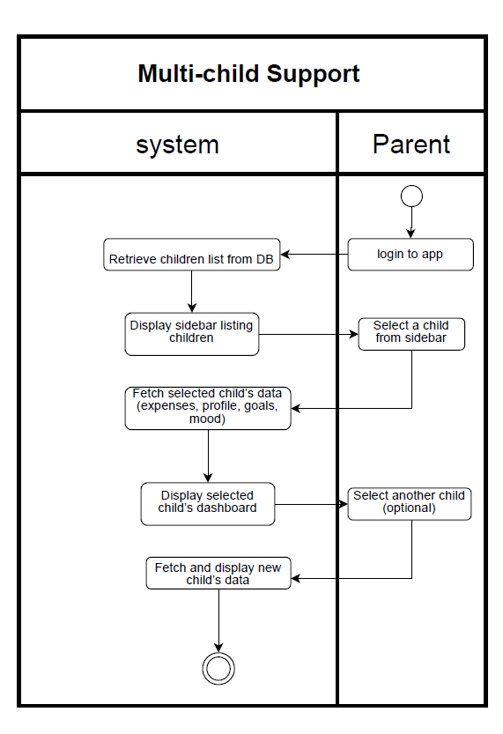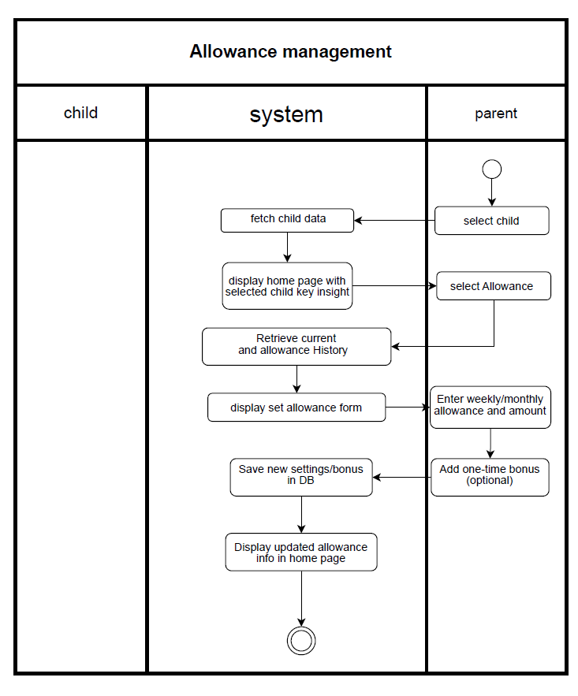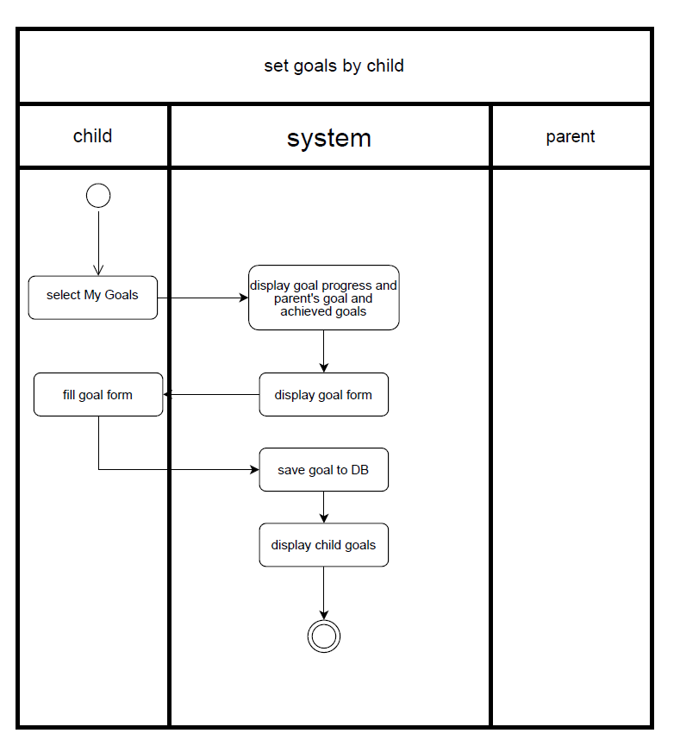
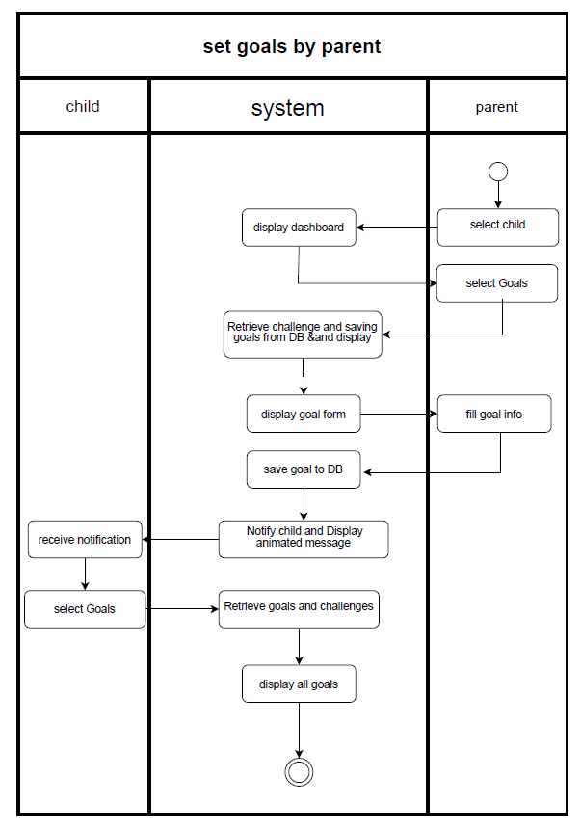

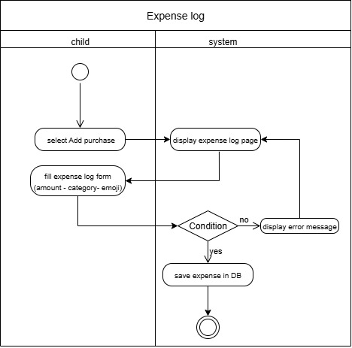

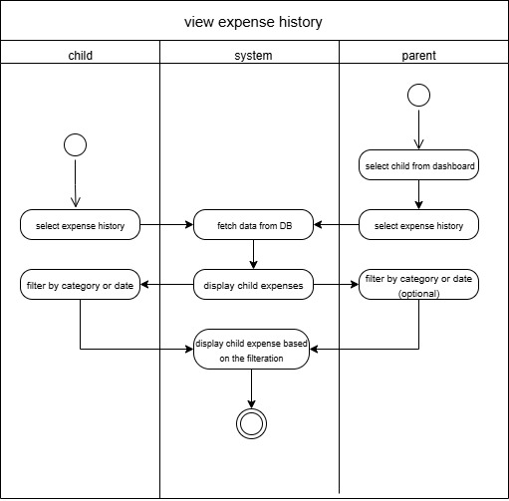

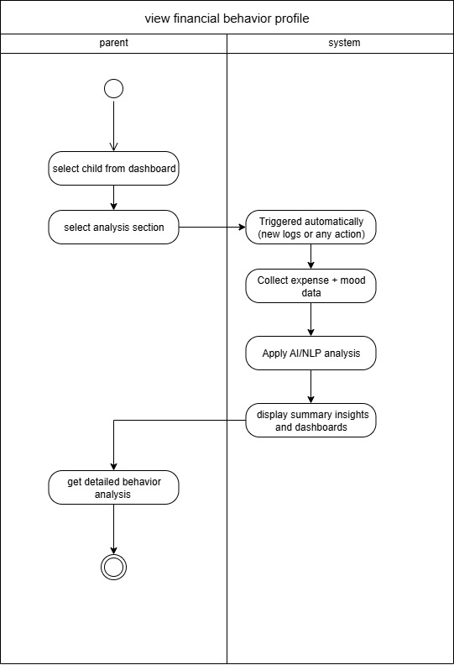

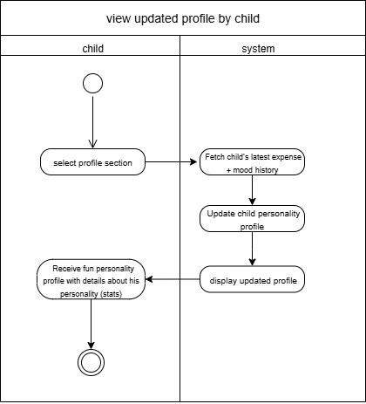

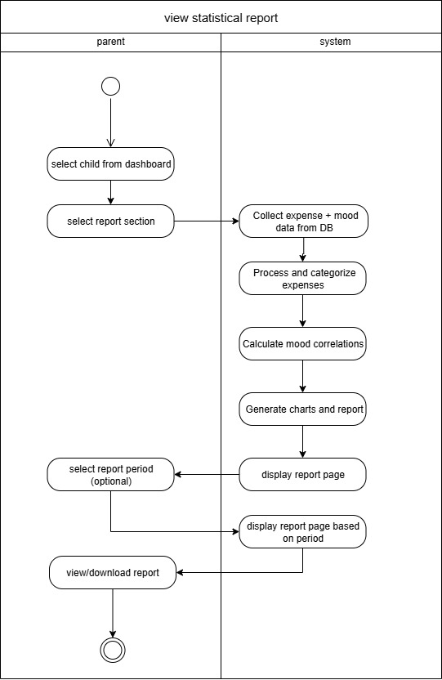
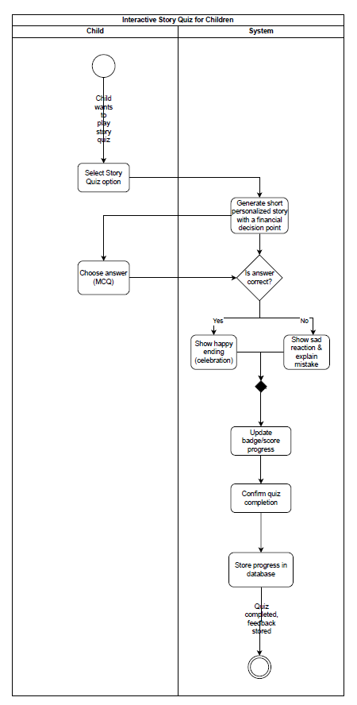
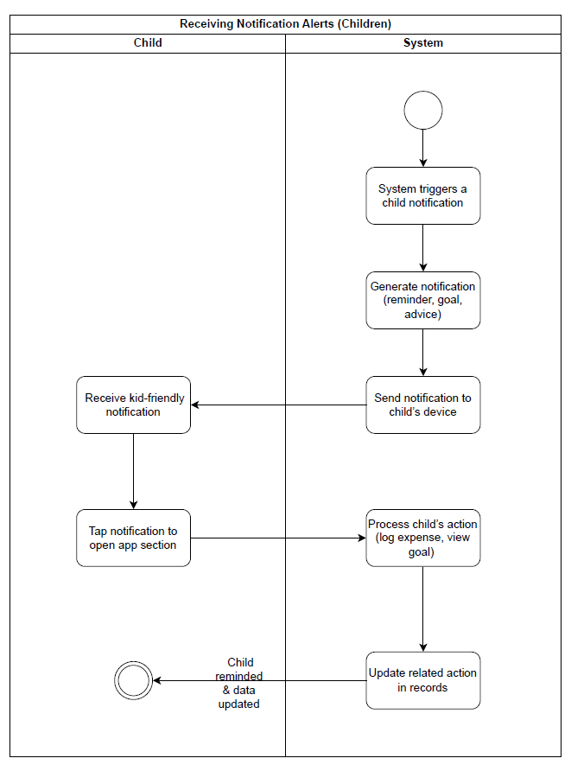
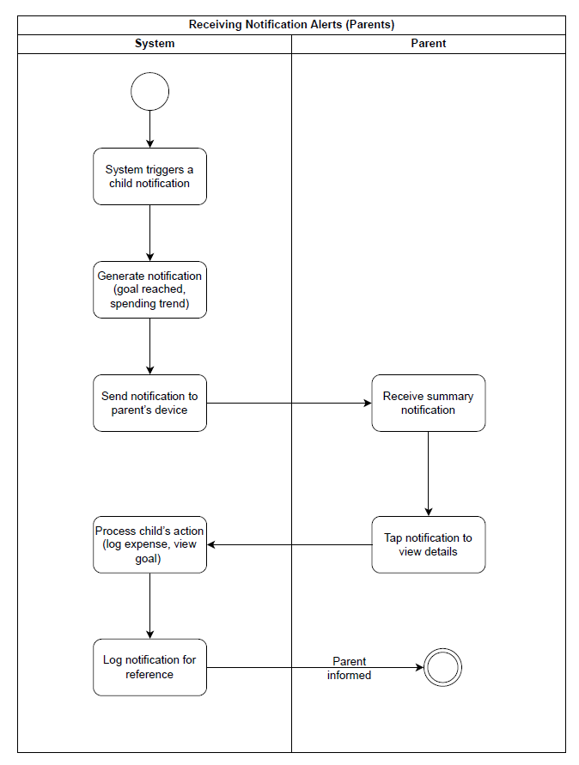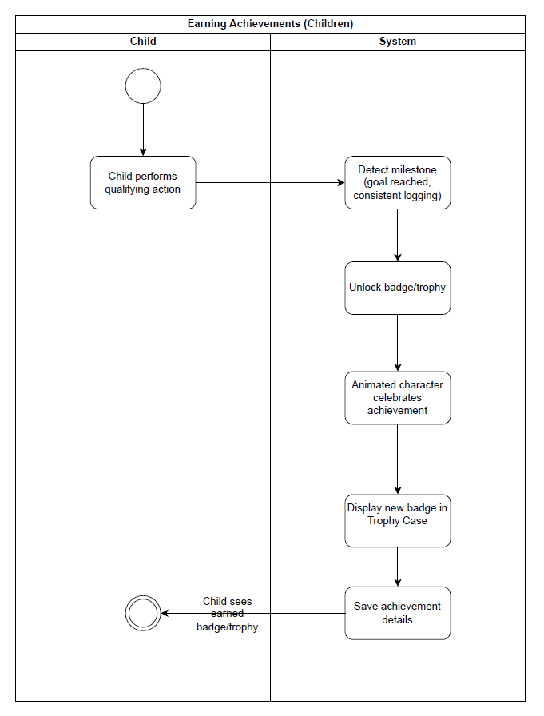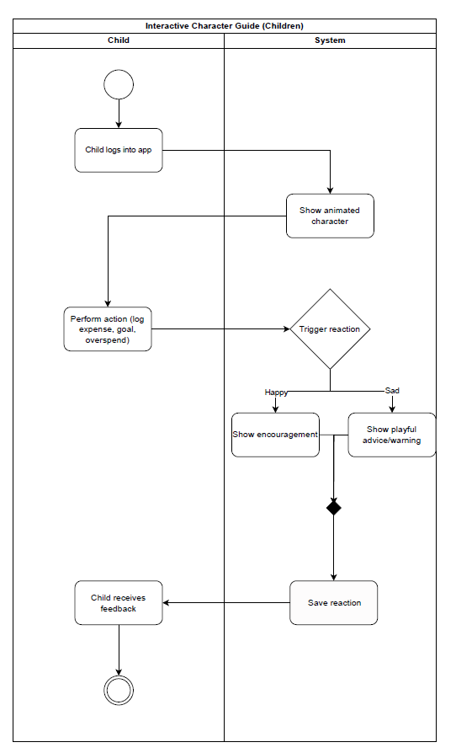
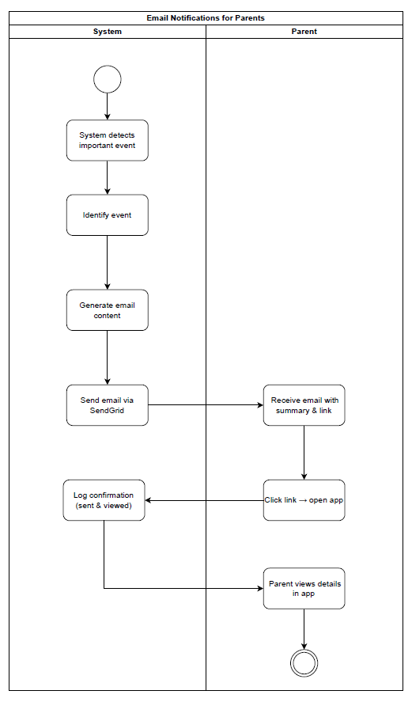

Feasibility Analysis

Executive Summary
Money Mirror is technically viable using cross-platform technologies (React Native, ASP.NET Core, SQL Server, spaCy/scikit-learn). No financial outlay is required from the project team; all tools are open-source. The target market shows strong demand and limited AI-driven competition. Risks are identified and mitigated through phased development. Overall, the project is highly feasible within the academic timeline.

Technical Feasibility

Aspect | Details
Required Technology | React Native (frontend), ASP.NET Core 6.0+ Web API (backend), SQL Server 2019+, Python (spaCy, scikit-learn, Transformers) via REST, Cloudinary (asset hosting), SignalR (real-time), SendGrid (email).
Hardware Requirements | Mobile: ≥4 GB RAM, ≥1.5 GHz CPU, Android 8.0+ / iOS 11+
Software Interfaces | JWT authentication, HTTPS API, role-based access control.
Expertise Needed | Team already possesses React Native, C#/.NET, SQL, and Python ML skills.

Market Feasibility

Target Market Analysis
- Primary Segment: Parents/guardians of children aged 6–14.
- Pain Points: Lack of visibility into children’s spending, difficulty teaching money concepts in an engaging way, absence of personality-aware guidance.

Competitors Landscape

Competitor | Core Features | Gaps vs. Money Mirror
Greenlight | Prepaid card + chores | No AI personality insights, limited gamification
Bankaroo | Virtual bank for kids | Basic categorization, no behavioral analytics
GoHenry | Debit card + tasks | Transactional focus, minimal learning modules

Money Mirror Differentiation:
- AI-driven personality profiling (NLP + mood logs).
- Gamified learning (story quizzes, animated character guide).
- Dual-interface (parent analytics + child engagement).

Risk Analysis
Risk Level | Probability | Impact | Description | Risk Type
High | Medium | High | Challenges in developing or integrating the AI-based personality analysis module. | Technical Risk
High | Low | High | Possible data breaches or unauthorized access to children’s and parents’ information. | Data Security Risk
Medium | Medium | Medium | Application slowdowns or crashes under high user load. | System Performance Risk
High | High | Medium | Low user adoption or limited engagement from target users (parents, schools). | Market Adoption Risk
Medium | Low | High | Non-compliance with child data protection laws. | Legal & Compliance Risk

Mitigation Strategy | Risk Type
Divide AI development into incremental phases with regular testing; use reliable and well-documented libraries or APIs. | Technical Risk
Implement end-to-end encryption and use secure databases. | Data Security Risk
Conduct regular performance testing. | System Performance Risk
Launch pilot programs with selected schools or parent groups; gather feedback to refine features before a full-scale release. | Market Adoption Risk
Regularly update the app to remain compatible with new Android and iOS versions. | Technology Obsolescence Risk
Conduct user testing sessions with children and parents; continually refine the UI/UX based on feedback. | User Experience Risk

Nonfunctional Requirements

Performance Requirements
- The system shall load the child dashboard (expenses, savings goals, achievements) within few seconds under normal network conditions.
- Parents’ analytics reports (spending breakdown, mood correlation) shall be generated within a couple of seconds after request.
- Personalized advice and story generation (AI-driven) shall respond within 10 seconds to maintain usability.
- The system shall support at least 500 concurrent parent-child accounts without performance degradation.

Safety Requirements
- Parents have full control over financial data visibility; children only see simplified, age-appropriate views.
- Backups of financial logs, personality profiles, and AI insights shall be taken daily to avoid data loss.
- Children’s experience will be safeguarded with content filtering (no negative or inappropriate advice generation).

Security Requirements
- All users (parents and children) must authenticate via secure login.
- Parent accounts require strong passwords.
- Sensitive data (e.g., allowance history, behavior insights) shall be encrypted in the database (SQL Server).
- Role-based access control ensures that children cannot access parental dashboards or financial reports.

Software Quality Attributes
- Correctness: Financial logs and analytics must reflect accurate values as entered by the child or processed by AI.
- Usability: Child UI must be colorful, engaging, and simple, while parent UI must provide clarity and detail.
- Flexibility: Easy addition of new features (e.g., new achievement types, extra quiz modules).
- Maintainability: Code shall follow standard conventions (React, ASP.NET Core) for easy debugging and extension.
- Reliability: Daily financial logs and AI insights shall not be lost even in case of crash (auto-save mechanism).
- Testability: Unit tests and integration tests will ensure all core features (expense logging, advice generation, reports) perform as intended.
- Robustness: The app shall handle unexpected inputs (e.g., invalid expense amounts, corrupted notes) gracefully with error messages.

